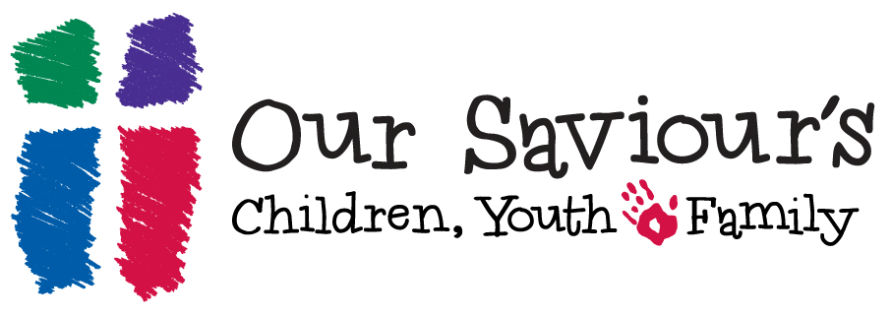
Together in Faith 2014-2015 Calendar

Milestone Ministry Parent-Child Classes: Each year OSLC offers parent-child courses to support parents in their baptismal promises and to equip families to talk about faith. Please look for a letter with more details but mark your calendar for these dates to come to the Sunday School hour with your child.

Splash! Families with children 0-3 Pastor Leta Behrens
November 9th 10:00am in the Nursery

Preschool: Forgiving!
November 2, 9, Worship 16 Pastor Leta Behrens &
Intern Pastor Diana Linden-Johnson

Kindergarten: Lord’s Prayer Colleen Waido
November 2, 9, Worship 16

1st Grade: Ten Commandments Kendra Hanson
January 25, February 1, Worship Feb 8

2nd Communion Instruction Pastor Leta Behrens
March 22: 9:45-10:45
March 29: 1:30-4:00—bread making and more!
Worship April 2nd 5:45—reception & pictures; 6:30pm—Maundy Thursday Worship

3rd Grade: Bible Robin Castor & Wanda Knauer
Feb 22, March 1, worship March 8

4th Grade: Apostle’s Creed Pastor Leta Behrens &__________
April 26, May 3 worship May 10

5th Grade: Martin Luther & MS Ministry Ruth Brown
November 2, 9, worship Nov 16

